**Lab report no 7,8**



**Fall 2022**

**Data Analytics Lab**

**Submitted By**

**Names Registration No**

Muhammad Ali 19pwcse1801

**Section**: A

**Date**: 21,12,22

**Submitted** to: Engr. Faiz Ullah

Department of Computer Systems Engineering

University of Engineering and Technology, Peshawar.

**Data Analysis using python-pandas**

Pandas is a popular Python library used for working in tabular data (similar to the data stored in a spreadsheet). Pandas provides helper functions to read data from various file formats like CSV, Excel spreadsheets, HTML tables, JSON, SQL, and more.

Considering an example of day-wise Covid-19 data for Italy in the tabular form as follows, **date,new_cases,new_deaths,new_tests**

2020-04-21,2256.0,454.0,28095.0

2020-04-22,2729.0,534.0,44248.0

2020-04-23,3370.0,437.0,37083.0

2020-04-24,2646.0,464.0,95273.0

2020-04-25,3021.0,420.0,38676.0

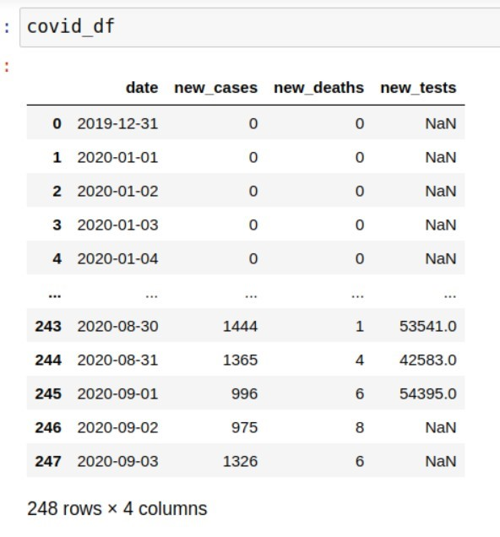2020-04-26,2357.0,415.0,24113.0

2020-04-27,2324.0,260.0,26678.0

2020-04-28,1739.0,333.0,37554.0

This format of storing data is known as comma-separated values or CSV.

We can now import the pandas module. As a convention, it is imported with the alias pd.

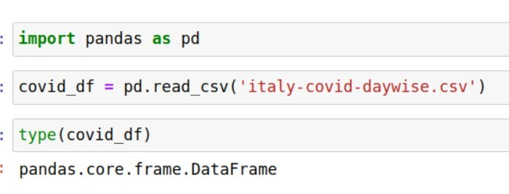

Data from the file is read and stored in a DataFrame object - one of the core data structures in Pandas for storing and working with tabular data. We typically use the _df suffix in the variable names for dataframes.

Here's what we can tell by looking at the dataframe:

* The file provides four day-wise counts for COVID-19 in Italy
* The metrics reported are new cases, deaths, and tests
* Data is provided for 248 days: from Dec 12, 2019, to Sep 3, 2020

Keep in mind that these are officially reported numbers. The actual number of cases & deaths may be higher, as not all cases are diagnosed.

We can view some basic information about the data frame using the .info method.

It appears that each column contains values of a specific data type. You can view statistical information for numerical columns (mean, standard deviation, minimum/maximum values, and the number of nonempty values) using the .describe method.

* pd.read_csv - Read data from a CSV file into a Pandas DataFrame object
* .info() - View basic infomation about rows, columns & data types
* .describe() - View statistical information about numeric columns
* .columns - Get the list of column names
* .shape - Get the number of rows & columns as a tuple

**Tasks:**

Find the total number of reported cases and deaths related to Covid-19 in Italy.

Find the overall death rate (ratio of reported deaths to reported cases).

Find the overall number of tests conducted? A total of 935310 tests were conducted before daily test numbers were reported.

Find the positive rate i.e. fraction of tests returned a positive result.

**Tasks no 1: -**

import pandas as pd

covid_df = pd.read_csv('italy-covid-daywise.csv')

newt_cases = covid_df['new_cases'].sum()

t_deaths = covid_df['new_deaths'].sum()

newt_test = covid_df['new_tests'].sum()

**Tasks no 2: -**

ratio = (t_deaths / newt_cases)*100

print('total no of death in itlay ',ratio)

**Output: -**

total no of death in itlay 13.073679170579894

**Tasks no 3: -**

initial_test = 935310

t_cases = (initial_test + newt_test)

print('total cases in itlay ',t_cases)

**Output: -**

total cases in itlay 5214766.0

**Tasks no 4: -**

t_newcases = covid_df['new_cases']

positivety = ( newt_cases /t_cases )*100

print('positivety in itlay ',positivety)

**Output: -**

positivety in itlay 5.206657403227681

**Lab report no 8**

**TASK 1: -**

Display the graph of death cases verses months.

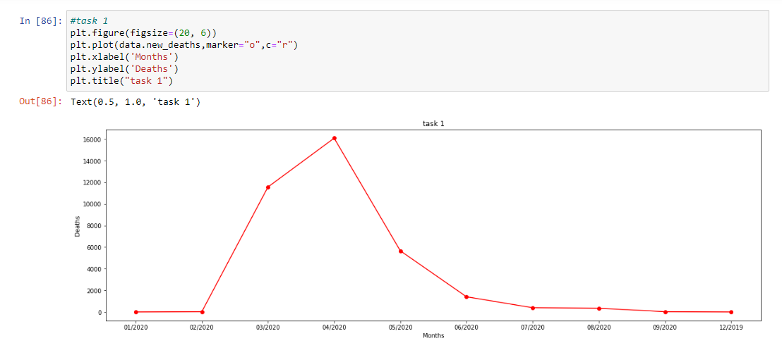

**TASK 2:**

Display the graph of new cases verses months.

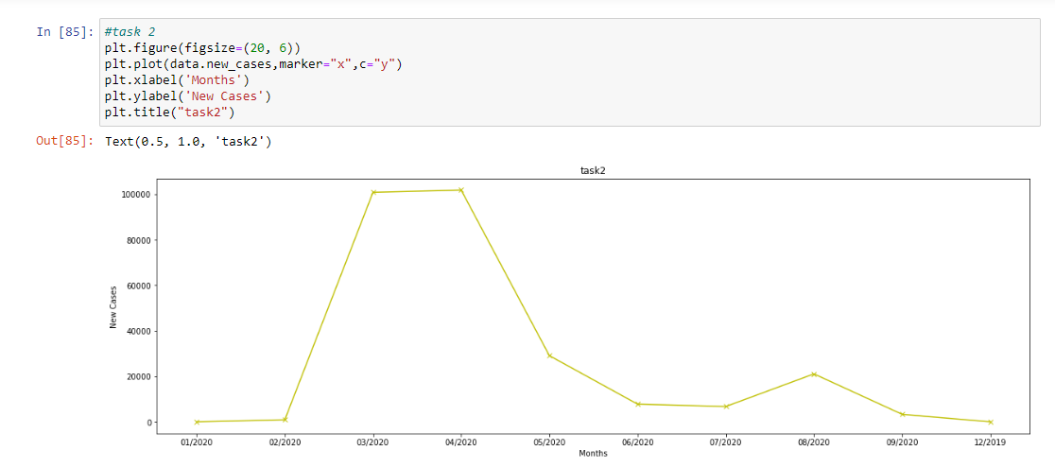

**TASK 3: -**Compare the new cases and death cases day-wise on multi-line graph, mark the legends and properly label and title the graph.

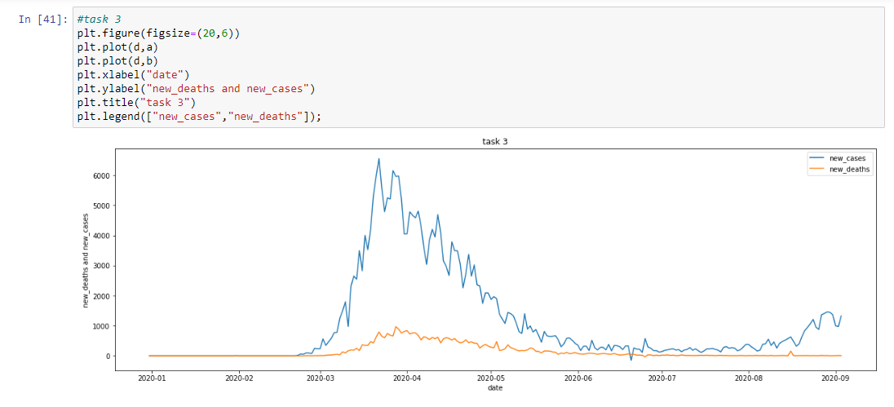

**TASK 4: -** Display how the new cases and new tests are related day-wise on multi-line graph, markthe legends and properly label and title the graph.

